Step:

0. Copy or take a picture of your Moai settings and advanced settings

**\*Moai resets all settings to default**

1. Download the latest Moai firmware from:

<https://drive.google.com/open?id=0Bzke6lBHG_z5U2padWxOVGNFUXM>

2. Find a SD card, format it

3. Extract the files from the firmware zip files into root directory of SD card



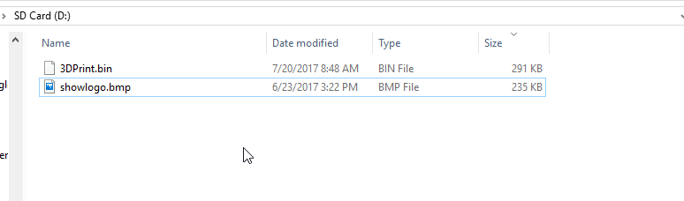

4. Power off Moai.

5. Insert SD card with the new firmare and logo files to Moai

6. Power on Moai, the screen will be dark while the power button lights up. Please wait for it to complete. **DO NOT POWER OFF**

7. After awhile, you will then see Peopoly logo on the screen as it turns on.

8. Your Moai firmware is updated, **it resets all the Moai settings to default**

9. Use the settings you kept to change Moai setting back to your liking.